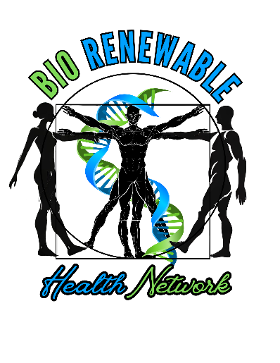

**Are you an "Alternative" or "Non-Traditional" Medicine Provider? A wellness business looking to connect with like-minded professionals?**

Welcome to **The BioRenewable Health Network**!!

We are a vibrant community of health and wellness practitioners in the South Jersey area, dedicated to offering authentic and holistic solutions for health and well-being. Whether you're involved in alternative therapies, complementary medicine, or any wellness-focused business, the BioRenewable Health Network provides a platform for networking, collaboration, and growth.

But we offer more than just connection! The BioRewnewable Health Network is designed to support your business in all areas by bringing in **expert speakers and resources** from a variety of fields tailored specifically to meet the needs of alternative and wellness-focused businesses. This includes:

* **Marketing strategies** to help you reach your target audience
* **Web design and online presence** to enhance your visibility and credibility
* **Business development coaching** to help you grow and sustain your practice
* **Graphic design** to create impactful branding and promotional materials
* **Community and Charity events** to share with the public
* And much more!

**Plus, we host a weekly podcast** featuring interviews with our network members. This is an exciting opportunity to showcase your business, share your expertise, and connect with a broader audience. Our podcast highlights the diverse talents within the BioRenewable Health Network and offers valuable insights on alternative health and wellness practices.

Our mission is simple: To unite professionals who are passionate about transforming the way health is delivered, empowering people to achieve their best physical, emotional, and mental health. Through our shared expertise and commitment, we help each other thrive and inspire the communities we serve.

Join us and expand your network with other passionate professionals who are redefining wellness. Let’s work together to elevate health and wellness in our region, while gaining the tools and resources to grow your business effectively!

Email us at BioRenewableHealth@gmail.com and let us know you wish to join

Visit BioRenewableHealth.org for more information

**Executive Board**

The entire network will have an executive board consisting of President, VP, Secretary, Treasurer and 1 Marketing Executive. As the network grows, the board will grow, adding 2 more general members starting at 50 total network members and increasing by 2 more general executive members for every 30 network members after that. The odd number of executives will allow for non-tying votes on topics of discussion. The executive board members can also serve as a Chair or Vice Chair of the division to which their business falls under. Should overall membership be below 30, there does not have to be a Chair and/or Vice Chair of any division. If the network is below 15 members, the board will have a President/Treasurer, VP/Marketer, and Secretary. The marketer will be responsible for setting up podcast guest as well as recruiting new members. The treasurer and secretary will provide usual tasks per their titles. The VP and president will organize events and run meetings and elections.

**Divisions**

Each division will have a Chair and Vice Chair to hold division meetings, research their area of wellness, maintain lists of products and recommendations, and report back to the entire membership and the public their findings.

* Bodywork
  + Includes exercise, massage, chiropractic, acupuncture, PT, etc
* Mindfulness
  + Includes spirituality, meditation, frequency healing, etc
* Nutrition
  + Includes supplements, water, farming, diets, CBD, medicine alternatives, foraging, alternative drinks, etc
* Pets
  + Includes food, medications, flea and tick remedies, etc
* Tech/Devices
  + Includes IR lights, grounding mats, PEMF, light and sound devices, TMS, LifeWave, wearable tech, cell phones, EMF protection, etc
* Education/Kids
  + Includes home schooling, summer camps, fitness programs, advocacy, performance psych, self-esteem, etc
* Clothing/Aesthetics/Body and Household Products
  + Includes natural fiber clothing, natural skin care, organic cleaners, soaps, shampoos, deodorants, storage containers, etc

Each Division will be featured on the podcast 1-2 times per year to discuss their research and recommendations and help promote the network and its charity cause. This can be done with the Chair, Vice Chair or any member of the division.