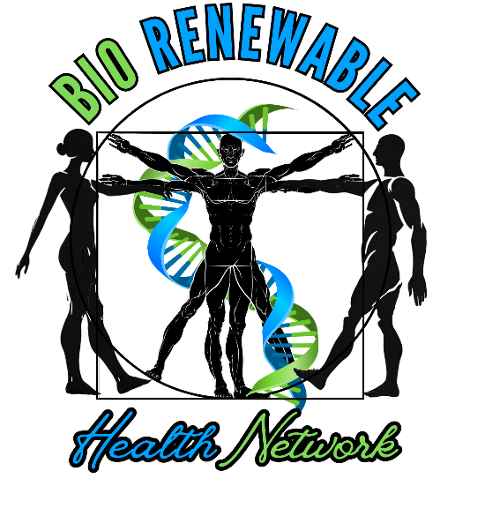

Podcast Concept

The BioRenewable Health Network Podcast is a dynamic platform exclusively designed for alternative health and wellness business owners, like you, to share your expertise, services, and products. As an extension of our thriving private member association, this podcast amplifies your voice while raising awareness of the health solutions our communities have come to value.
Being a guest on the BioRenewable Health Network Podcast means you’re not just promoting your business, but engaging in meaningful conversations about effective therapies, natural health resources, and local products that make a difference. Every episode will showcase current members, offering a unique opportunity to build connections.
Sponsorship and advertising slots are also available, giving your business even more exposure. Whether you’re a guest or a sponsor, your message will reach a highly engaged alternative health audience. This reach will be further supported by social media clips promoted across our platforms and shared with outside companies and charities to inform the public of your unique stance in the alternative health and wellness field.
The podcast will feature a high quality production that reflects your brand. And thanks to our initial sponsor, Integrated Hyperbarics, covering equipment, there is no cost for members to be a guest. Plus, you’ll have access to perks like multiple guest appearances depending on your BioRenewable Health Network membership level.
Join us, share your story, and be a leader in alternative health on the BioRenewable Health Network Podcast!
Contact The BioRenewable Health Network for more information on being a guest or sponsor BioRenewableHealth.org/The-BioRenewable-Health-Network
And be sure to tune in each week at YouTube.com/@BioRenewableHealth

